Geography – Long Term Overview – Cycle A & B
Yr R  Cycle A Cycle B  On-going throughout the year through child-led and objective led planning | Development Matters: Understanding the World – The World
 | 30-50months  • Comments and asks questions about aspects of their familiar world such as the place where they live or the natural world.  • Can talk about some of the things they have observed such as plants, animals, natural and found objects.  • Talks about why things happen and how things work.  • Developing an understanding of growth, decay and changes over time.  • Shows care and concern for living things and the environment. |  |  | 40-60 months  • Looks closely at similarities, differences, patterns and change |  |  | Early Learning Goal  Children know about similarities and differences in relation to places, objects, materials and living things.  They talk about the features of their own immediate  environment and how environments might vary from one another. They make observations of animals and  plants and explain why some things occur, and talk about changes.
 | Autumn 1 | Autumn 2 | Spring 1 |  | Spring 2 | Summer 1 |  | Summer 2
EYFS | Snack time circle times: children to talk about their own home and community life, and to find out about other children’s  experiences.  • EAL children to have opportunities to use their home language / share vocabulary some of the time  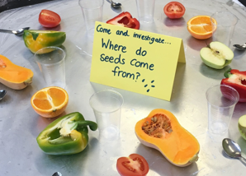  Compare citrus fruit: where would we get them from? (local)  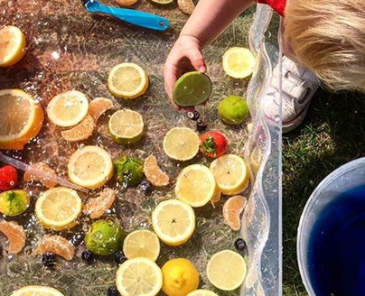 | Make a bridge for the bears to cross the river – name the geographical features in the story: woods / cottage / path / cottage / river / bridge  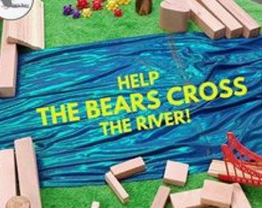  Learn about different cultures, e.g through Diwali – make Rangoli patterns / diva – where is India? Traditional clothing/music / dance (people)  Where is India? Where else do they celebrate Diwali? (world)  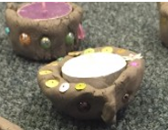 | Dinosaur world in builder’s tray – create and name features, such as river, ill, tree, rocks, etc  Welly walk  What features can we find in our garden and school grounds? Children draw and label key features, e.g. garden, sandpit, tree, field, playground, bench, wild area.  In classroom, adult model drawing and labelling a simple picture map of the features found on the welly walk. Which ones are made by man/nature? |  | Welly walks – exploring school grounds and immediate local area:  * Arouse awareness of features of the environment in the  setting and immediate local area, e.g. visit to shops and the park.  • Introduce vocabulary to enable children to talk about their observations and to ask questions.  ELG:  - notice and discuss patterns around them,  e.g. rubbings from grates, covers, or bricks, tarmac, fake grass area  • Use appropriate words, e.g. ‘town’, ‘village’, ‘road’,  ‘path’, ‘house’, ‘flat’, to help children make distinctions in their observations.  • Help children to find out about the environment by  examining photographs and simple maps and visiting local place: school grounds/ Beaulieu river by the field / Beaulieu high street & village hall.  ^ Shapes in our environment  Story maps – looking at different settings in the Hampshire Picture Book awards – Where are the stories taking place? What is the place like? How is it the same/different to…?  Creating a simple story map with key features.  Beebot story maps  Remote control cars – travelling from one place to another – mix of natural and man-made, e.g Beaulieu Abbey, New Forest, village hall, Beaulieu High Street, etc | 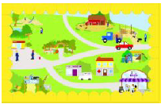  Using Simple City to visit, explore ad discuss the different places on the map. Discuss the features of the Simple City map and the features of the maps within.  Purple Mash - Slideshow creator – using pictures of places around the school and local environment, including walk around the school and local area and creating own ‘Simple’ City style map.  • Help children to find out about the environment by talking to people, (visit to Beaulieu Fire Stations)  • children encouraged to develop positive relationships with  community members, such as fire fighter, nurses, vets, police who visit the setting  Welly Walks  • Encourage children to express opinions on natural and built environments and give opportunities for them to hear different points of view on the quality of the environment – discussion after welly walk to school grounds, Beaulieu River and the High Street  • Encourage the use of words that help children to express opinions, e.g. ‘busy’, ‘quiet’ and ‘pollution’.  - Litter picking walk – views on litter |  | Insects and habitats in our garden – where can we find them? What is their habitat like?  Building minibeast homes to help them survive – which are the best locations for the,, e.g bees, butterflies, worms, snails etc?  • Help children to find out about the environment by  examining photographs and simple maps and visiting local places – farm / Testwood Lakes – how is this place different to our school grounds?  - Compare sea to the farm  Welly walks  - Minibeasts in our school grounds  - Patrick’s garden – differences / changes in plants – express opinion when comparing the High Street to Patrick’s Patch  - Garden centre – compare to Patrick’s garden  - Redwood outdoor garden area  Pirate maps -

KS1 Yr1 /2 | Autumn 1 | Autumn 2 | Spring 1 | Spring 2 | Summer 1 | Summer 2
Cycle A Topic | What’s Great About Beaulieu Village? | London’s Burning  Light up | Australia | Hampshire Picture Book Award | Jack and the Beanstalk  Growing | Titanic
Geography | My local park  Maps and locational geography  UK map | Mini Unit: London/Beaulieu comparison | Are they here? Comparing London with Canberra. Australia. | Mini Unit: Continents and oceans | Mini Unit: UK map, 4 countries, capital cities

KS1  Yr1 /2 | Autumn 1 | Autumn 2 | Spring 1 | Spring 2 | Summer 1 | Summer 2
Cycle B Topic | - 1,2,3 It’s Good to be Me!  - We can Make a Difference | - I like to Move It, Move It!  - Penguin Small  - Christmas | Who is Afraid of the Big Bad Wolf? | Hampshire Picture Book S Awards | Down in the Jungle | Dragons
Geography | Locational Knowledge: World and UK map games Lepe Beach | START: Hot and Cold Places North / South Pole – compass.directions | COMPLETE: Hot and Cold Places  Where else are wolves found? Continents and oceans. |  | REVISIT: Locational Knowledge: World and UK map games ‘jungles / rainforests

KS2  Year 3/4 | Autumn 1 | Autumn 2 | Spring 1 | Spring 2 | Summer 1 | Summer 2
Cycle A Theme | Frozen Planet | Me and my Shadow  Light Up | Anglos Saxons | Fragile Earth | Vulgar Vikings | Bon Voyage!  France
Geography | The Vatnajokull National Park is a world away from The New Forest National Park.  Geographical similarities and differences between ‘The New Forest National Park, UK’ with the ‘Vatnajokull National Park’. Iceland. |  | Mini uniti: Where did the Anglo Saxons settle and what changes resulted? | Volcanoes and Earthquakes  Volcanoes are more dangerous than earthquakes. | Mini unit: Viking invasion - maps | La Plagne is a world away from our local area.  Compare with region in Europe  Framce – European study  Ski resort – La Plagne

KS2  Year 3/4 | Autumn 1 | Autumn 2 | Spring 1 | Spring 2 | Summer 1 | Summer 2
Cycle B Y3/4  Theme | Chocolate | Doctor, Doctor | Tomb Raiders | Madagascar | Roman Rampage | Rivers
Geography | Economic Activity  What is unique about chocolate Chocolate / Ivory Coast – UK link with Ivory Coast |  | Brief map work: Where is Egypt? | Mini unit: Where is Madagascar?  What is it like? | Brief map work: Where is Rome? | Rivers  All rivers are the same as Beaulieu River.  Compare to the River Nile and an European river

KS2  Year 5 /6 | Autumn 1 | Autumn 2 | Spring 1 | Spring 2 | Summer 1 | Summer 2
Cycle A Theme | Ancient Greece | Coastal erosion (Land Ahoy) | Mayans | Rivers: The Amazon |  | UK
Geography | Brief map work: Where is Greece? | Does Hampshire do enough to look after our coasts?  Coastal erosion / use of ordinance survey maps /compass points | Brief map work: Where did Mayans originate and settle? | Rivers  Are all rivers the same as our local One?  Rivers: Local/ River Tees / The Amazon |  | UK: Loctional knowledge  What and where are the human and physical features of the UK?

KS2  Year 5 /6 | Autumn 1 | Autumn 2 | Spring 1 | Spring 2 | Summer 1 | Summer 2
Cycle B Theme | Global Explorers | Victorians | South America, Peru | World War 2 | North America | Early Civilizations
Geography | Natural resources  Is every country equal?  UK, Australia, Russia  - Economic activity  - Distribution of natural resource including energy, food, minerals, water |  | Biomes and Climates  Which Biome is the easiest to live in?  South America, Peru | Mini unit: Countries of World War 2 (Europe focus) | North America  New York is a world away from our local area.

