 | Beaulieu Village Primary School: Computing Scheme of Work Overview
We use Purple Mash as our core overview. For Internet Safety the school also use resources from HeartSmart and the Thinkuknow website. The school participates in the Safer Internet Day each February.
At Beaulieu Primary we support word processing skills through BBC Dance Mat Typing.
Coding will be taught in sequence.

Willow Year R – Cycle A and B - Overview
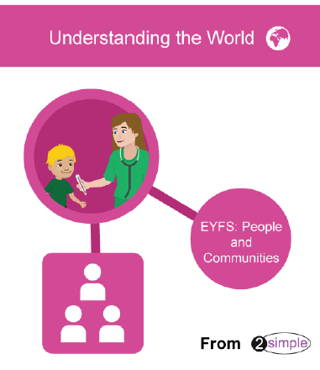 | Throughout the year children will also access Purple Mash – UW – People and communities – through circle times – to discuss feelings and customs and traditions – through topics, pins: all about me and feelings.
 | Autumn 1 | Autumn 2 | Spring 2 | Spring 1 | Summer 1 | Summer 2
 | Use the interactive whiteboard (Active Inspire) and paint program on tablets for painting and drawing tools and to give the children experiences of working together to create their own pictures (PSED Making friendships & EAD link)  Using the tablet to take photos of children, learning, things made in the classroom. Share photos with friends / ask if friends happy to have their photos taken. Making and playing back short videos - link to Purple Mash planning – PSED – making relationships  Children learn that PhonicsPlay can help with our learning of rhyme and phonics. | Selfie – photos using the class tablets - wearing hats – linked to hat shop  Introduce laptops - use of Purple Mash – learning to log on (with support) – introducing a password. Exploring Mini Mash – using two fingers / hands to control the mouse.  Developing PSED – self-confidence through exploring Mini Mash and talking about what they have found out – trying new things  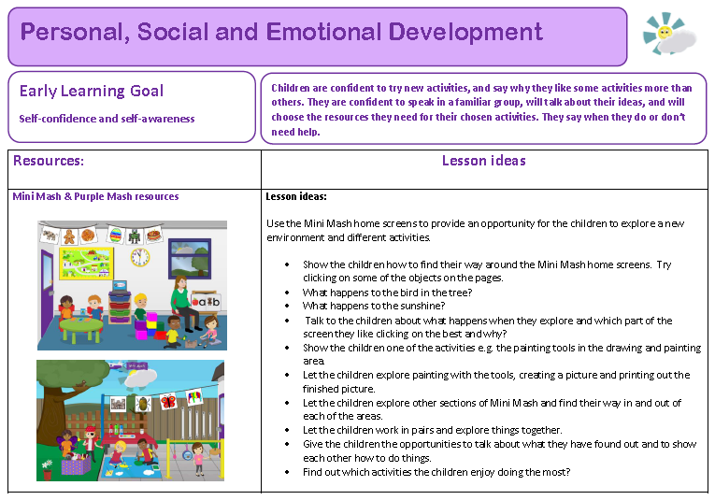  Using iwb (Active Inspire) to make a picture for a calendar | Safer Internet Day (whole school) – February  Communicating Online Discussion Activity  Internet Safety  https://www.thinkuknow.co.uk/5_7/  Practising logging onto Purple Mash and using the password (still with support if needed to locate keys on the keyboard) – encouraging children to say why we need a password.  Use the interactive whiteboard (Active Inspire) and paint program on tablets for painting and drawing tools – adding labels and captions (Literacy: writing link)  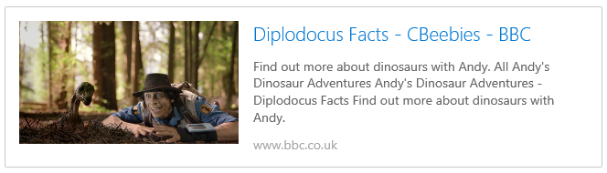  Using class tablets to watch cbeebies dinosaur clips  PSED Making Relationships  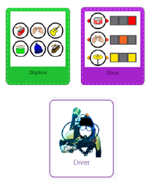  Using 2beat to create music – PSED Making Relationships (mouse control) and working together as a ‘band’ to create music on laptops and tablets – making decisions, taking turns, working together – developing strategies for working together and turn taking, e.g. sand timer, numbers out of a hat,  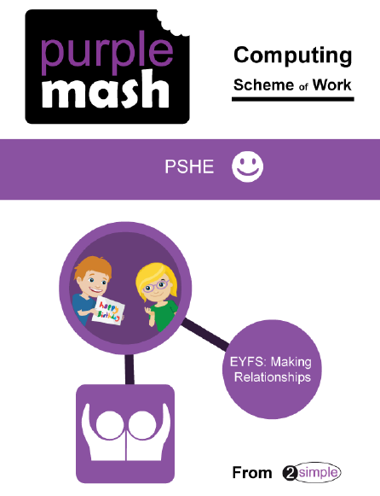 | Remote Control cars  Beebots – exploring story maps – link to Hampshire book awards.  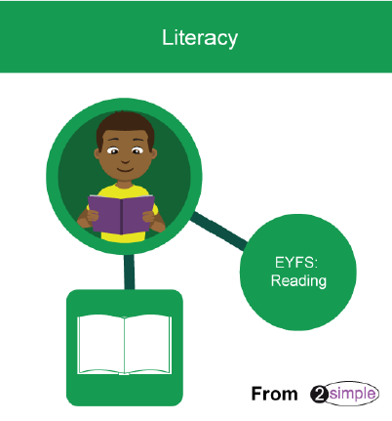  Use the mashcam to create a character – add speech bubbles – write and read what they say.  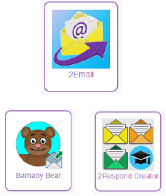  Use Purple Mash 2Email / 2Respond – to write and reply to a character from one of the Hampshire Picture Books.  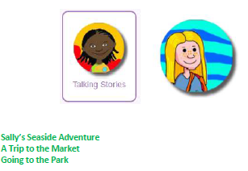  Use PM – Talking Stories – then leave on iwb / laptop /tablet in book corner for children to access and read.  Use 2Connect to model how to plan a story – children then plan a story – record story on tablet using video.  Create a page about one of the characters from the stories (Hampshire Picture Book award)  Create a book cover for a book that the children will write (for a giant or other character) | Magnifer on computer  Beebot  Different uses of technology – at home / school / environment  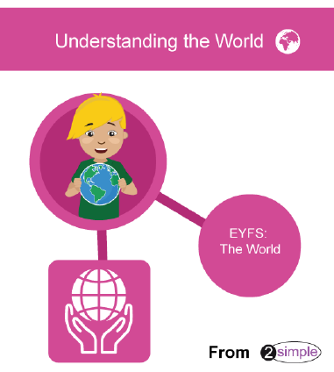  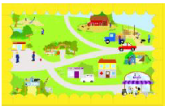  Using Simple City to visit, explore ad discuss the different places on the map. Discuss the features of the Simple City map and the features of the maps within.  Slideshow creator – using pictures of places around the school and local environment, including walk around the school and local area and creating own ‘Simple’ City style map. | Logging onto the laptops and Purple Mash independently.  Purple Mash  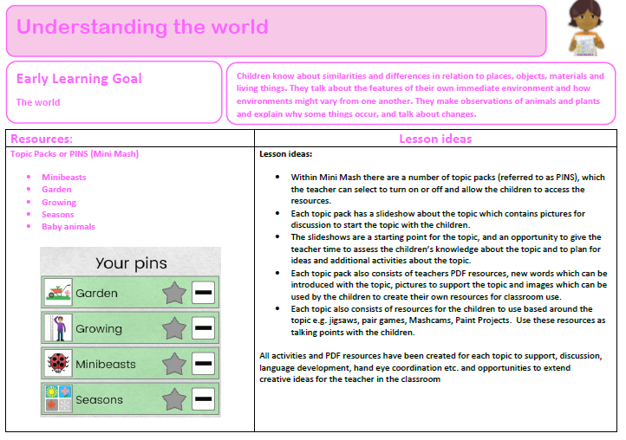  Finding out about gardens, Minibeasts, growing, baby animals and Seasons.  2Connect – children make notes of what they already know about a subject before they research – then add to their web diagram.  Use Purple Mash 2Email / 2Respond – adult to write an email inviting children on a school trip (Longdown or Testwood Lakes) - class reply.  Use the Internet to find out about Longdown or Testwood lakes  Link to Literacy Reading: Bad Tempered Ladybird – 2 Create a story – class book
Redwood – Year 1 & 2 Overview
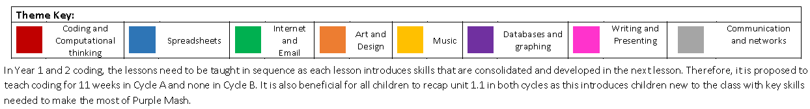
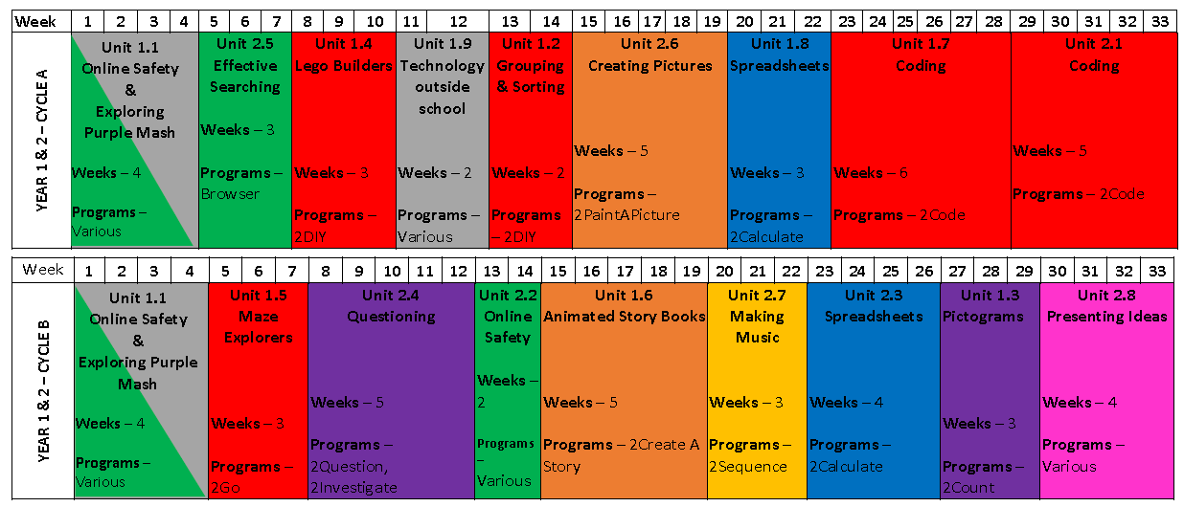

Chestnut – Year 3 & 4 Overview
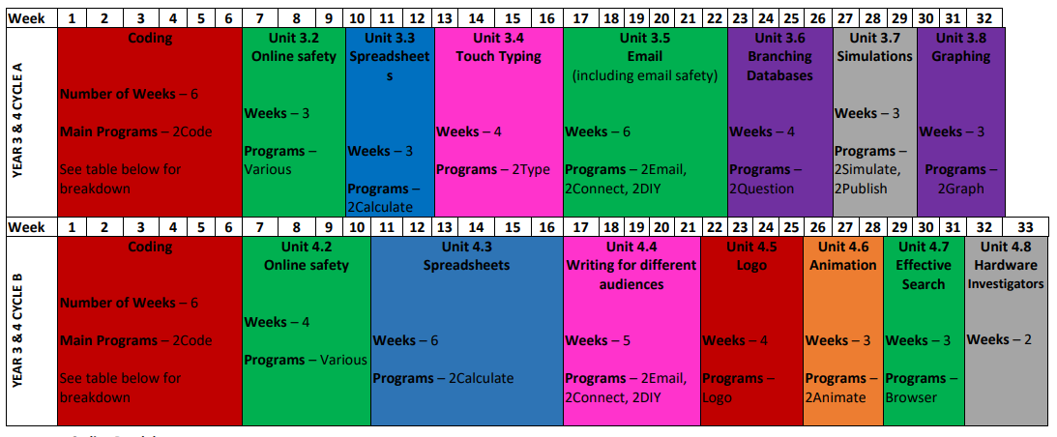

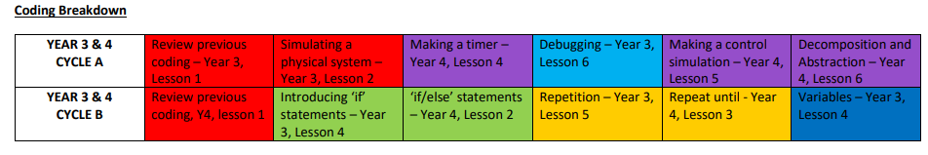
Oak – Year 5 & 6 Overview
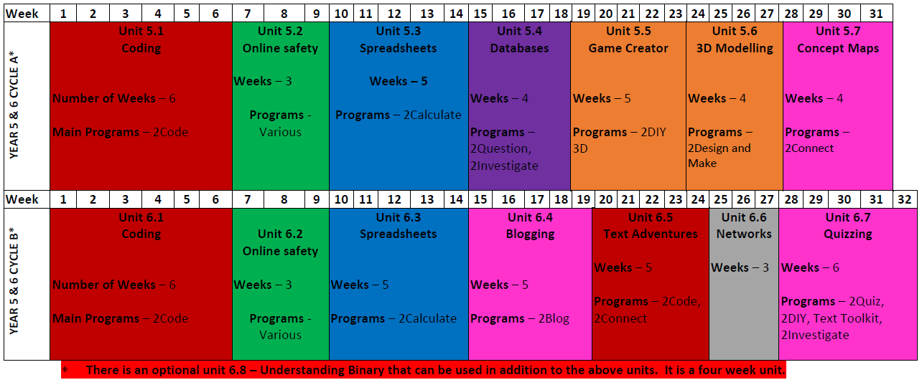
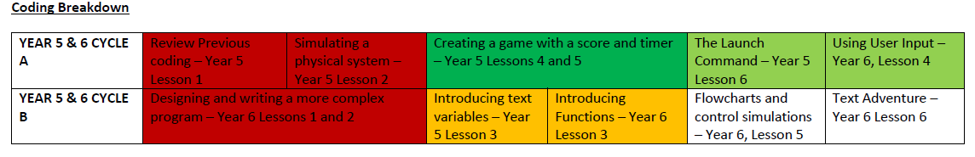
CLASS and Focus | KS1 Objectives  Redwood – Y1/2 | KS2 Objectives  Chestnut – Y3/4 | KS2 Objectives  Oak – Y5/6
Computer Science | • understand what algorithms are; how they are implemented as programs on digital devices; and that programs execute by following precise and unambiguous instructions  • create and debug simple programs  • use logical reasoning to predict the behaviour of simple programs | • design, write and debug programs that accomplish specific goals, including controlling or simulating physical systems; solve problems by decomposing them into smaller parts  • use sequence, selection, and repetition in programs; work with variables and various forms of input and output  • use logical reasoning to explain how some simple algorithms work and to detect and correct errors in algorithms and programs
Searching |  | • use search technologies effectively, appreciate how results are selected and ranked, and be discerning in evaluating digital content
Digital Literacy  Multimedia and Data | • use technology purposefully to create, organise, store, manipulate and retrieve digital content | • select, use and combine a variety of software (including internet services) on a range of digital devices to design and create a range of programs, systems and content that accomplish given goals, including collecting, analysing, evaluating and presenting data and information
Use of Technology | recognise common uses of information technology beyond school |  | • understand computer networks including the internet; how they can provide multiple services, such as the world wide web; and the opportunities they offer for communication and collaboration  • use search technologies effectively, appreciate how results are selected and ranked, and be discerning in evaluating digital content
E-Safety | • use technology safely and respectfully, keeping personal information private; identify where to go for help and support when they have concerns about content or contact on the internet or other online technologies.  Class Acceptable Use Policy  Heart Smart unit: keeping safe  Thinkuknow  February: Safer Internet Day
E-Safety /  Digital citizenship |  | • use technology safely, respectfully and responsibly; recognise acceptable/unacceptable behaviour; identify a range of ways to report concerns about content and contact.  Class Acceptable Use Policy  February: Safer Internet Day
E-safety and families | Purple Mash: parent advice | Hampshire e-safety resources - Resources | Code-It:  Communicating Online Discussion for Families

