Newsletter 18 – Friday 12th June 2026
Dear Parents/Carers,

Beaulieu’s Best

Over the last two weeks we enjoyed celebrating with the following children who have really embraced our school values, Have Courage, Be Kind, Shine!

Seb Tabitha Mabel Eli Charlie
Jack Zoya Otis Daisy O-S Emilia
Pearl Isabel G

Well done everyone!

Dental Hygiene Show

On Monday 8th June, our Key Stage 1 children enjoyed a fantastic visit from the Praizin' Hands Puppet Group, a charity based nearby in Hythe. Through an engaging puppet show filled with lively songs, music and rhymes, the children learnt all about the importance of dental hygiene. The interactive performance taught the children the vital routine of brushing their teeth twice a day for two full minutes. We hope our KS1 pupils are excited to put these fun healthy habits into practice at home!

“I liked the toothbrush song, you have to brush your teeth for 2 minutes to make sure they are clean!” Amirah
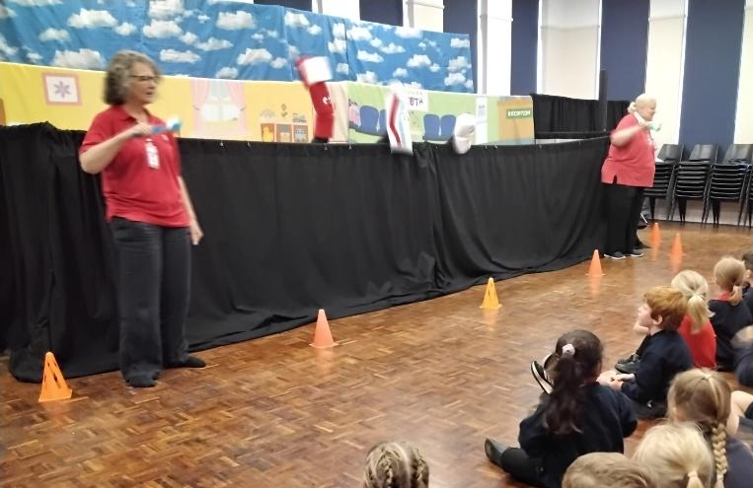
“It was funny when the birds popped up and started dancing to the music.” Tommy

“I liked the toothbrush, he was called Captain Bristles and I liked the toothpaste puppet.” Finn

“It was a really good show, you only need a pea sized dot of toothpaste!” Atlas



New Forest Activities Centre Adventure

A huge thank you to Sam Sutton and Rich Pearsall, two of our parents, for inviting the children in Oak class to a free fun filled trip to the New Forest Activities Centre on Monday 8th June. Despite the weather, the children really enjoyed taking part in a low ropes course, a blindfolded teamwork activity called 'Nightline' and a high ropes course. The children challenged themselves and encouraged each other, they had a fantastic time!

"Everyone was really generous by cheering other people on and it was one of my best experiences! The staff were extremely kind." Elyza.

"The staff didn't just teach us how to be brave, they taught us to encourage other people and to use teamwork." Millie

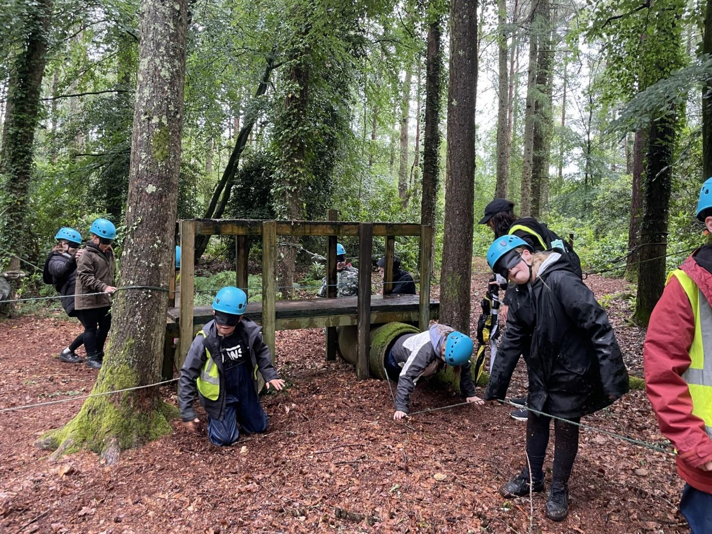

Well Done to the Children in Year 1 and Year 4


We were incredibly proud of all of the children in Year 1 and Year 4 this week for the determination, resilience and positivity they have shown during their phonics screening (Year 1) and Multiplication Checks (Year 4). The children have worked exceptionally hard throughout the year and they should all feel very proud of themselves. Well done — you have been amazing! The children’s results will be shared with parents at the end of the year with annual reports.
EP Workshop: ‘Supporting Your Child’s Transition to Secondary School’
It was lovely to see so many parents at our recent transition workshop that was led by our school link Educational Psychologist, Sophie-Jayne. The session covered the ways that parents can support their child with transition to Secondary as well as ways that parents can support themselves with this transition. If you came along, we hope that you found the session useful.


Sports Day

We are really looking forward to Sports Day next week. Just to remind you, family members are invited to join us for a family picnic on the school field from 12 noon. Races will begin at 1pm. Please bring along a chair or blanket to sit on.
Please remember to send your child into school on the day in their school PE kit with a T-shirt in their house colour:
Agamemnon | Swiftsure | Triton | Illustrious

There will, as always, be a parent and carer race. Please note that the school accepts no liability for any injuries that may occur.

Sailing Club Update

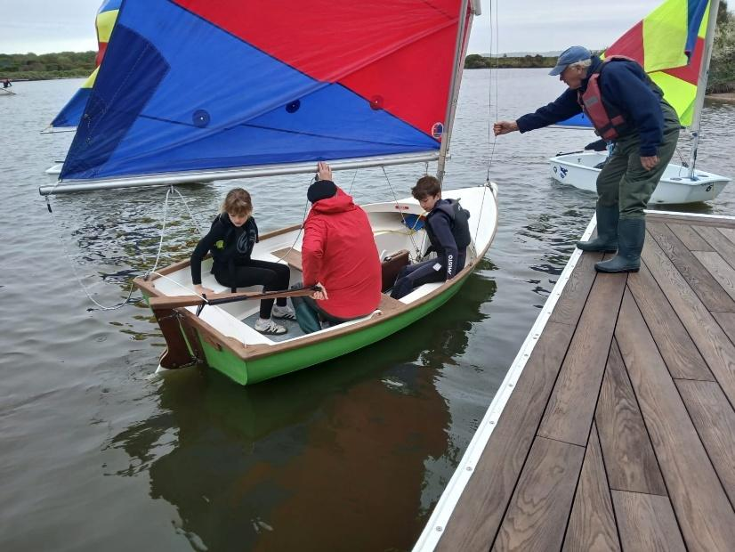
The children (and parents) had a great time at Sailing Club this week and all of the sailors completed a capsize drill. This is something that most of the children look forward to, but it can be a scary prospect for the new sailors. The following children completed a capsize for the first time and showed lots of courage.

Y6 - Ewan and Jude
Y4 - Martha, Olivia and Rory
Y2 - Annabel, Loveday, Charley, Isla, Eleanor and Brooke
Y1 - Archie and Adam

Well done everyone!


Village Fete - Saturday 18th July

We are all looking forward to this years’ village fete which takes place on Saturday 18th July. The Year 5/6 maypole dancing will begin at 12:40pm on the lower lawn.

The organisers have said that they are a bit short of volunteers to help take down the gazebos and tidy up at the end of the fete. The team start the breakdown at 4.00pm. If you are able to help, please email Nick Hubbard: nickhbd@aol.com.
Thank you.

Have a lovely weekend.

Best wishes,
Michelle Hale
Headteacher

Sport Reports:
Year 3 and 4 Tennis – Wednesday 10th July 2026
Hello my name is Martha and I was lucky enough to join some of the year 3s and 4s at the tennis competition at Priestlands this week. We all played really well and we got 1st place. Marley did some good hits and Felix got 64 points which was amazing! I was really proud of all my friends and we all had great fun. Bethany and Otto also did some good serves.
Well done everyone.

Hi my name is Mia and I was also lucky enough to go with year 3 & 4 to Priestlands for tennis. Henry did some amazing serves and gained a lot of points! Martha managed to do some incredible volleys. Vincent and Alice got the wristbands for teamwork!!! It was really fun even though it was raining most of the time. Emma shook hands at the end of every game and we were all really proud of our medals. Raife also did some great volleys. Reef did good serves. All our points were put together to make 536. It was a great team effort!!!!!!

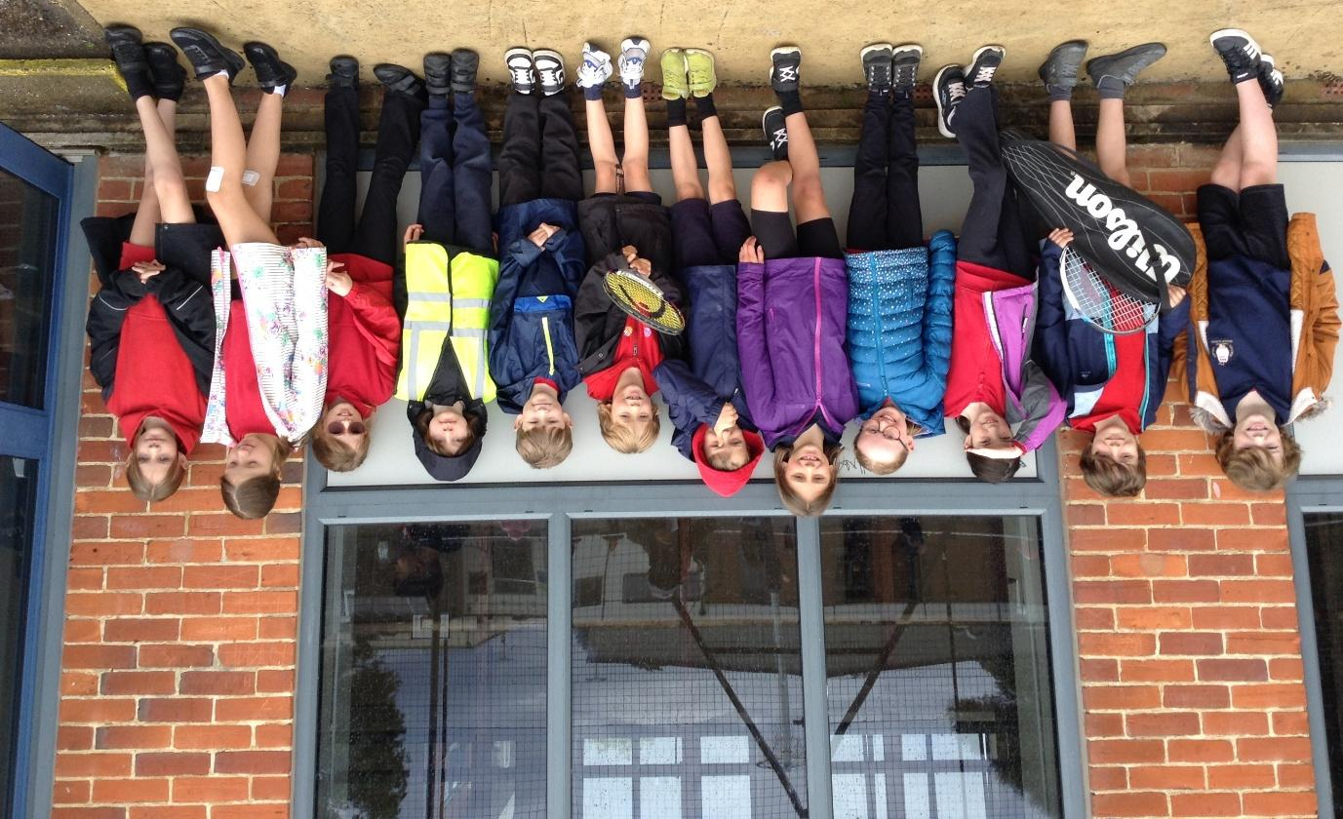

Diary Dates 2025- 2026
New dates in red
Day | Event | Notes
Wednesday 3rd June | Sports afternoon | All children need to wear their PE kit
Wednesday 3rd June | Induction Meeting for new Year R parents at 6pm
Thursday 4th June | Celebration Assembly with Year 2 home achievements
Monday 8th – Friday 12th June | Year 1 Phonics Screening Week
Thursday 11th June | Celebration Assembly with Year 1 home achievements
Tuesday 16th June | 2-3pm New Year R Stay and Play Session 1
Wednesday 17th June | Sports Day | Parents are invited to join us for a picnic lunch on the field
Tuesday 23rd June | 2-3pm New Year R Stay and Play Session 2
Wednesday 24th June | Sports Day – reserve date
Thursday 25th June | Celebration Assembly with Year R home achievements
Wednesday 1st July | Sponsored walk to Buckler’s Hard– new date
Wednesday 1st July | Work Sharing 3-3.30pm
Thursday 2nd July | 2-3pm New Year R Stay and Play Session 3
Wednesday 8th July | Class swap – meet new class teachers
Thursday 9th July | 2-3pm New Year R Teddy Bears’ Picnic
Thursday 9th July | KS2 Performances | Afternoon and evening performances
Friday 10th July | KS2 Performance | Evening performance
Wednesday 15th July | Class swap – meet new class teachers
Wednesday 15th July | Cyber Protection training for children in the juniors
Wednesday 15th July | FOBS Summer BBQ
Thursday 16th July | Maypole Dancing Showcase – all classes | 3pm on the school field
Saturday 18th July | Beaulieu Village Fete | 12 noon onwards
Monday 20th – Wednesday 22nd July | Picnic Lunches available for the children
Monday 20th July | Lord and Lady Montagu’s Summer Tea Party | Afternoon event
Tuesday 21st July | 2.30pm Year 6 Leavers’ Service | Parents welcome
Wednesday 22nd July | Beaulieu’s Got Talent | Morning event
Thursday 23rd July – Monday 31st August | SUMMER Holiday 2026
INSET Days for 2026-27
- Tuesday 1st September 2026
- Wednesday 2nd September 2026
- Friday 23rd October 2026
- Monday 2nd November 2026
One more date to follow.


