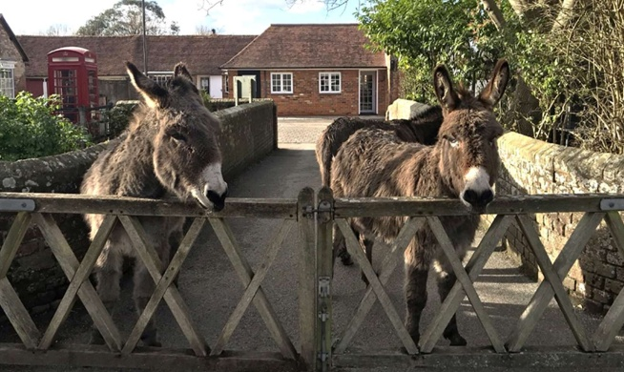
For more information please contact the school office adminoffice@beaulieu.hants.sch.uk

To find out more about being a school governor in Hampshire visit www.hants.gov.uk/governors-volunteer
The role of school governor is subject to a DBS check.

“Governors bring experience and provide meaningful oversight. They provide well-judged support and challenge. Through structured visits and committee work, governors test leaders’ evaluations and maintain a clear understanding of pupils’ experiences, including for disadvantaged pupils and those with special educational needs and/or disabilities.” Ofsted 2026

We meet at the school twice a term on a Wednesday evening for full board meetings, and once per term some governors sit on committees (to suit skills and experience) during the school day.
You will be part of a supportive and pro-active team of volunteers working to deliver the best possible education for children in our community and we offer training to develop and enhance your skills.

A school governor ensures that:
- the vision, ethos and strategic direction of the school are clearly defined
- the headteacher effectively drives the educational performance of the school
- the school’s financial resources are used efficiently
To be a school governor you do not need a background in education – we value a diverse range of skills and interests.

We are looking for a dedicated person to join our school board of governors
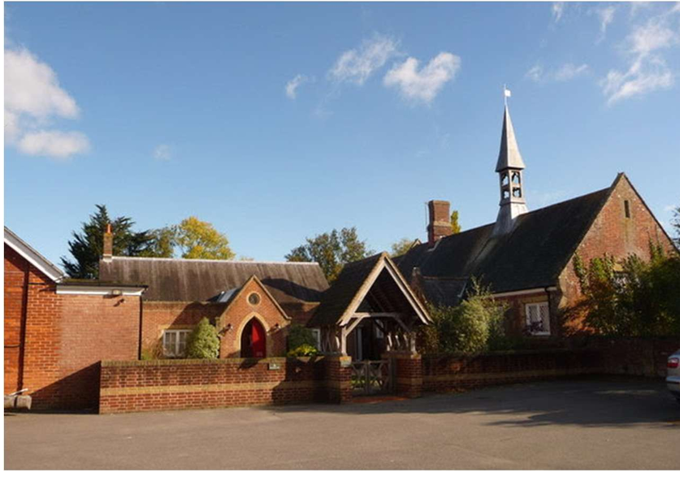

Beaulieu Village Primary School
www.beaulieuschool.org.uk

